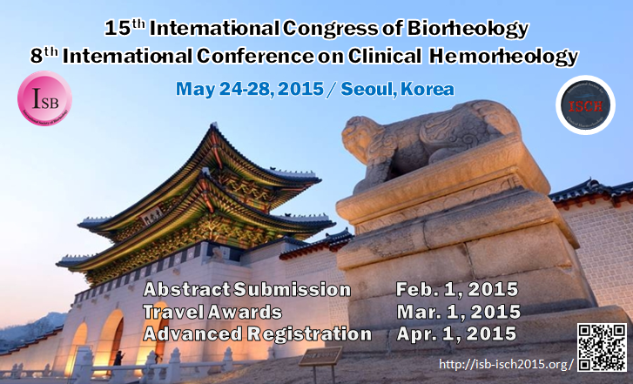
On behalf of the Organizing Committee, we are very pleased to invite you to the 15th International Congress of Biorheology and 8th International Conference on Clinical Hemorheology (ISB-ISCH 2015) to be held on May 24-28, 2015 in Seoul, Korea.

[ISB-ISCH2015 Website] - http://isb-isch2015.org/main/

Important Dates
- Abstract Submission : February 1, 2015
- Travel Award : March 1, 2015
- Advanced Registration : April 1, 2015
Abstract Submission
Authors wishing to submit an abstract are kindly advised to refer to the submission guideline at
http://isb-isch2015.org/sub/sub03_03.asp?menu=3
and submit their abstract via online by February 1, 2015.
It is required to sign up first at the conference website before submission.
Abstract of papers should be less than 300 words in English.

For the detailed information on the topics as well as the important dates, please see the electronic leaflet attached below :
ISB-ISCH2015_Leaflet

Topics for Symposia include but are not limited to:
- Biofluid/Biosolid Rheology and Mechanics
- RBC/WBC/Platelet Rheology
- Bio or Hemorheology for Pharmacology
- Mechanobiology or Rheological Aspects of Cells/Tissue/Vascular
- Molecular Biorheology
- Bio or Hemorheology in Microcirculation
- Clinical disorders and rheology
- Cellular engineering
- Biorheology of Cancer
- Artificial Organ
- Sensors, Measurements and Methods for Bio or Hemorheology
- Micro/Nano fluidics for Bio or Hemorheology
- Diagnosis/optical coherence tomography
- OCT application to computational hemorheology

Registration Guide
Categories | On or Before April 1, 2015 | After April 1, 2015 | On-Site
Society Member (ISB or ISCH) | $500 | $570 | $650
Non-Member | $650 | $700 | $780
Post-Doctoral Fellow | $350 | $400 | $450
Student | $250 | $275 | $300
Accompanying Person | $100 | $100 | $100
Banquet | $50 | $50 | $50
*The Banquet is free for registered accompanying persons.

You can also find the further information on the symposium website at http://isb-isch2015.org/.

Contact Information
Conference Co-chairs : Sehyun Shin (Korea University, lexerdshin@korea.ac.kr),
ByoungKwon Lee (Yonsei Univ. Severance Hospital, cardiobk@yuhs.ac )
Secretary General : Joon Sang Lee (Yonsei University, joonlee@yonsei.ac.kr)
Simon Song (Hangyang University, simonsong@hanyang.ac.kr)
ISB-ISCH 2015 Secretariat : Mihee Kim (02-501-5305/info@isb-isch2015.org)
Thank you.

